DAT 510 uCertify Lab Activity Worksheet

Module Labs
Module Two
2.6.1 Examining Data
2.6.2 Exploring Underlying Distribution of Data

Lab Screenshots
2.6.1 Examining Data
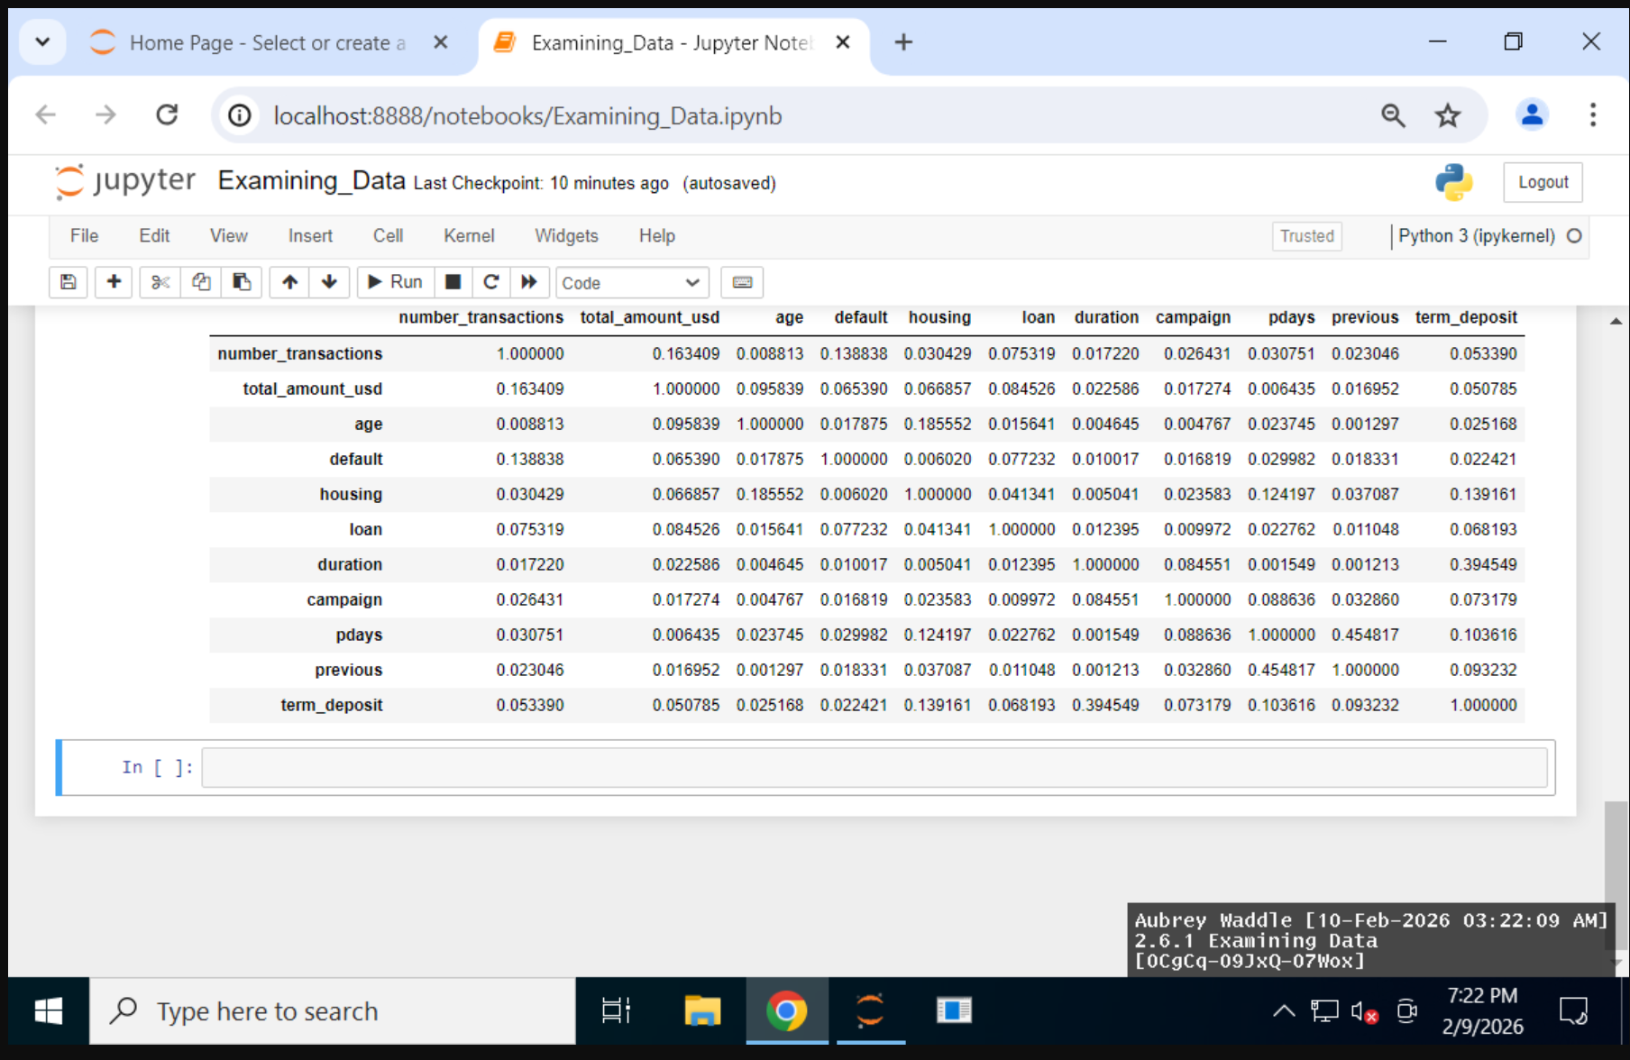

2.6.2 Exploring Underlying Distribution of Data
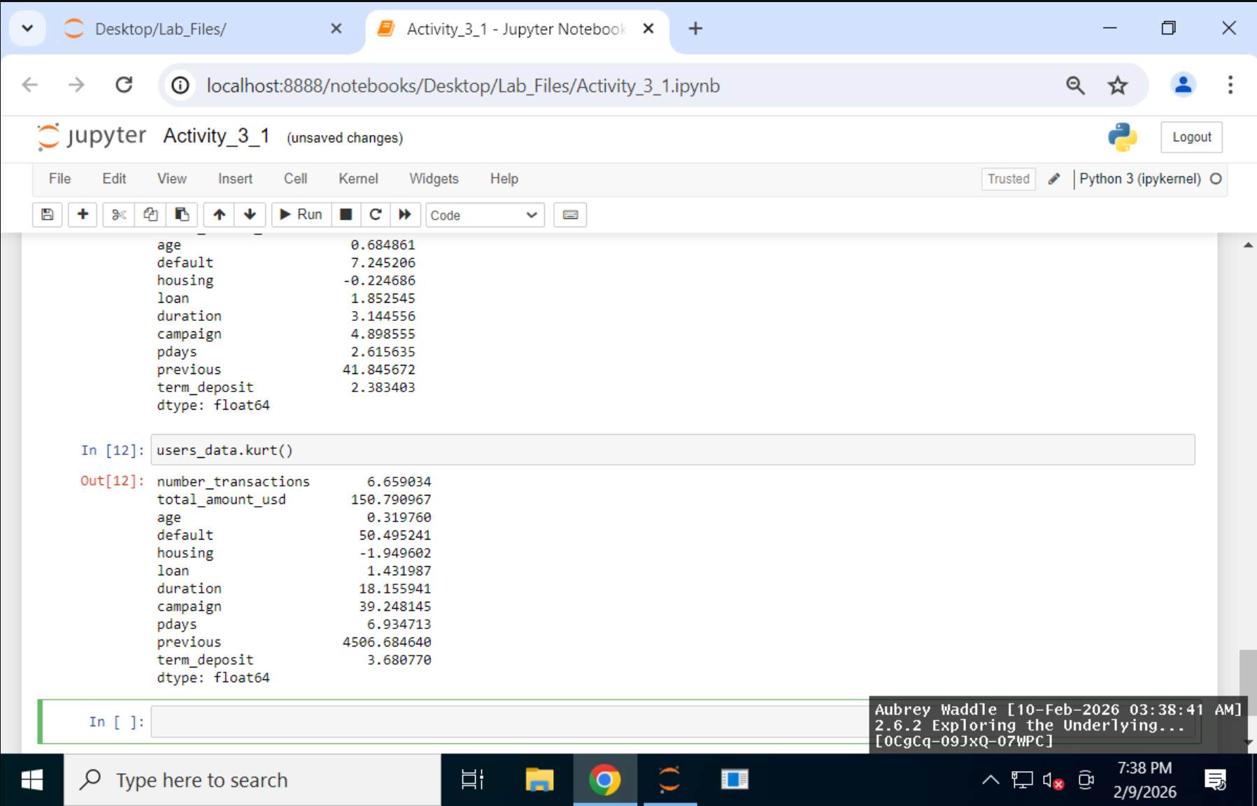

Lab Reflection

2.6.1 Examining Data
This week’s lab focused mainly on setting up a full Python data-analysis environment and then exploring a real dataset to understand its structure before doing any modeling. I used tools like NumPy and Pandas for handling and inspecting the data, along with SciPy, scikit-learn, Matplotlib, and Seaborn being imported for statistical analysis and visualization. Most of the work this week was more about the process of data exploration and preparation rather than building charts. I loaded a cleaned dataset, checked the first few rows, reviewed the dataset’s shape, confirmed unique user IDs, and used functions like .info() and .corr() to understand data types, missing values, and relationships between variables. Compared to labs where I focused heavily on visual dashboards, this one felt more technical and behind-the-scenes, centered on understanding the data before making decisions with it.
These skills are especially useful for data analysts, data scientists, or anyone preparing datasets for machine learning or reporting, because they help ensure the data is accurate and well-understood before analysis begins. The techniques would be most appropriate in professional environments where large datasets need cleaning, validation, or feature exploration before visualization or predictive modeling. While there weren’t many visualizations created this time, the correlation matrix and datatype grouping still served as analytical “views” into the data. Overall, this lab emphasized the importance of groundwork and data literacy, which is valuable for both technical teams and stakeholders who rely on accurate data insights.

2.6.2 Exploring Underlying Distribution of Data
This week’s lab was focused more on data exploration and statistical understanding rather than building visual dashboards. I worked primarily in Python using Pandas and NumPy to examine a large user dataset and understand its structure and distribution. I used functions like .describe() to generate summary statistics, .mode() to identify the most common values, and .drop() to remove unnecessary columns like user IDs that don’t contribute to analysis. I also calculated skewness and kurtosis to better understand how the data is distributed and whether variables were heavily skewed or had extreme outliers. Compared to previous labs that emphasized charts and visuals, this one felt more technical and numbers-driven, focusing on statistical properties behind the scenes instead of presentation.
These techniques are especially useful for data analysts, data scientists, and anyone preparing data for machine learning or predictive modeling, because they help identify outliers, bias, and data quality issues before modeling begins. While there were fewer visualizations this week, the statistical summaries served a similar purpose by giving a clear snapshot of trends and irregularities in the dataset. These skills are most appropriate in professional or research settings where accuracy and data validation are critical, such as finance, marketing analytics, or operations analysis. Overall, the lab highlighted the importance of understanding the shape and behavior of data before attempting deeper analysis or visualization.

